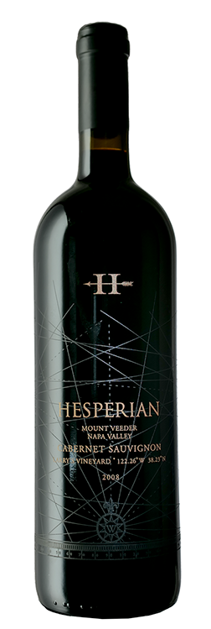

**Description:** Dark ruby color, the nose starts with a lot of earthiness that progressively lifts to reveal powdery floral aromas, minty, chaparral (growing all around the vineyard). The wine is smooth and dense. A slight graininess towards the end of the finish indicates the wine still a few years of life.

Single Vintage Back Story: Before I purchased Kitoko Vineyard in 2010,  I bought fruit from several single vineyards to make and bottle wines that showcase the terroir of various appellations in the Napa Valley.  In 2008, I crafted only 50 cases of wine each from Larry's Vineyard on Mt Veeder, Jeff’s Vineyard in Yountville, Harry’s Vineyard in Coombsville and Tom's Vineyard in Rutherford.  I also made 450 cases of a Napa blend from the four vineyards.

Winemaking Style: The techniques I learned in Bordeaux are nowadays considered a bit old style but it is this style of winemaking that made the beautiful wines that came out of Bordeaux in the 80s and 90s. I maintain this style because I believe this is what makes for beautiful age-worthy wines. The 2008s are at a peak now and we thought it would be great to make an offer now, for the holidays.  Enjoy them together with family and friends.

**The Vintage**: The 2008 wines always had a lot of charm. They were and still are very generous and voluptuous. This is due to the weather of this vintage. It was a dry vintage with a spring frost that lowered yields across the valley. In August there were massive fires in northern California that produced enough smoke high in the atmosphere to create a haze that slowed down maturation which allowed us to have a longer hang time. These two elements are the reason why the 2008 are so voluptuous.

ALCOHOL:  14.5% CÉPAGE:  100% Cab Sauvignon ÉLEVAGE:  19 Months, 60 % new French Oak PRODUCTION:  50 cases OPTIMAL AGING: 2020-2030

**2008 Hesperian Cabernet Sauvignon**

*Larry’s Vineyard, Mt Veeder, Napa*