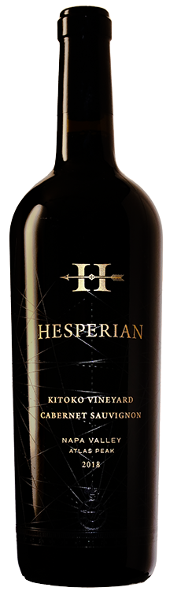
2018 Hesperian Cabernet Sauvignon
Kitoko Vineyard
Atlas Peak, Napa Valley

Description
Kitoko Vineyard leaps from the glass with notes of violet, chocolate-covered cherries, crème de cassis, stewed plums, and boysenberries, plus suggestions of grilled meats, hoisin, and fragrant earth. Medium to full-bodied, the palate is laden with black fruit preserves and spicy sparks, framed by plush tannins and bags of freshness, finishing long and earthy. It’s a structured, noble bottle of Cabernet Sauvignon that will age 15-20 years effortlessly.

Vineyard
100% from Kitoko Vineyard but more specifically a corner of the valley block and the Finger block, both harvest October 29.
Kitoko Vineyard, named for the Congolese Lingala word for “beautiful,” is a 14.2-acre vineyard high on Atlas Peak, planted to Cabernet Sauvignon in 2000 and 2003. The soils here are incredibly rocky, dry, and poor, quite like Pritchard Hill to the north, studded with fractured andesite rock and boulders. The proximity to the San Pablo Bay brings persistent winds, which along with the heat and arid soil, cause the set of very small berries and loose bunches, and consistently delay ripening each year. Dry farming is impossible here, and the vines are watered for short stretches to optimize ripening.

The Harvest
2018 was a consistently uneventful, generous, and
excellent vintage. The lowest Accumulated Growing Days of the past five years allowed for extended hang time and a late harvest. Harvest started September 23 and ended October 29.

Accolades

ALCOHOL LEVEL: 14.7 % CÉPAGE: 100% Cabernet Sauvignon ÉLEVAGE: 20 Months in 64% new French oak PRODUCTION: 325 cases OPTIMAL AGING: 2022 - 2038

O: 707.255.1256 | F: 707.255.1256 | INFO@HESPERIANWINES.COM | 3189 ATLAS PEAK ROAD ~ NAPA, CALIFORNIA 94558

