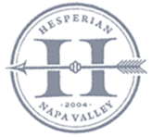

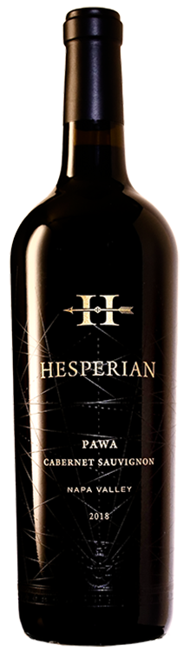
2018 Hesperian
Cabernet Sauvignon
Pawa, Napa Valley

Description

Pawa displays alluring scents of Black Forest cake, black currant cordial and blueberry compote, violet with hints of Indian spies, menthol, and espresso. The full-bodied palate is jam-packed with expressive black fruit preserves, framed by velvety tannins and fantastic freshness, finishing long, and layered.

Vineyard
69% of this wine comes from earlier picks from the Kitoko Vineyard, from 4 different parcels harvested in 5 picks. Named for the Congolese Lingala word for “beautiful,” Kitoko is a 14.2-acre vineyard high on Atlas Peak, planted to Cabernet Sauvignon in 2000 and 2003. The soils here are extremely rocky, dry, and poor, quite like Pritchard Hill to the north, studded with fractured andesite rock and boulders. The remaining 31% of the wine comes from the best barrels of Didier’s “Eagle’s Nest” Vineyard, in between Monticello Road and Milliken Creek in Napa.

The Harvest
2018 was a consistently uneventful, generous, and
excellent vintage. The lowest Accumulated Growing Days of the past 5 years allowed for extended hangtime and a late harvest. Harvest started September 23rd and ended October 29.

ALCOHOL LEVEL: 14.7%
CÉPAGE: 100% Cabernet Sauvignon
ÉLEVAGE: 20 Months in 31% new French oak PRODUCTION: 325 cases
OPTIMAL AGING: 2022 – 2028

O: 707.255.1256 | F: 707.255.1256 | INFO@HESPERIANWINES.COM | 3189 ATLAS PEAK ROAD ~ NAPA, CALIFORNIA 94558

